
Company
Logotype

Cone Beam Computed Tomography- Report



Porur Dental X-rays & CBCT

Patient Name : Mr. Ramakrishnan | Date of Report : 06.07.2024
Age/ Gender : 69 years/ Male | Region of Interest : CBCT Sectional Mandible
Referring doctor: Dr. V. Sasikumar | Indication : Implant assessment
Clinical Notes: Nil
PATIENT INFORMATION

CBCT- Sectional Mandible provided
CBCT – IMAGE DETAILS

RADIOGRAPHIC INTERPRETATION

- Complete loss of crown and root structure in relation to 47.
- The alveolar bone in relation to 46, 47 is present with normal trabecular pattern.
- In relation to 45, presence of hyperdense screw like structure is evident within the alveolar bone.
- Presence of hyperdense crown structures in relation to 41, 42, 43, 44, 45, 46.
- In 46, presence of hyperdense restorative material within the pulp canal extending upto the apical third of the root is evident.

IMPLANT ASSESSMENT

 | 46 region | 47 region
Sub-Crestal (in mm) | 10.95 | 8.28
Mid- Crestal (in mm) | 11.74 | 11.66
Distance between alveolar ridge and the inferior alveolar nerve canal (in mm) | 14.72 | 15.86
Distance between alveolar ridge and the inferior border of mandible (in mm) | 22.71 | 24.02

RADIOGRAPHIC IMPRESSION

- Partially edentulous region: 47.
- Crown in relation to 41, 42, 43, 44, 45, 46.

Kindly correlate with clinical findings


IMAGES FOR REFERENCE

RECONSTRUCTED PANORAMIC VIEW
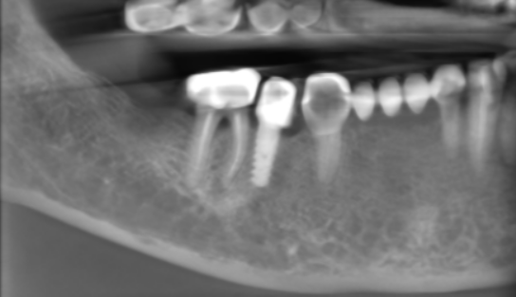

3-DIMENSIONAL VIEW

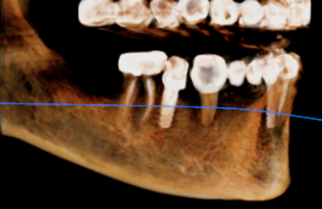

CROSS SECTIONAL VIEW

46 region | 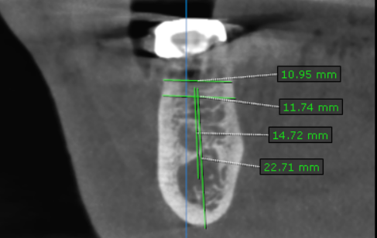
47 region | 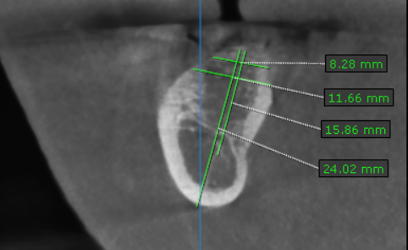

**** End of report ****

